Minification

Definition
# Source: AI Source: Provided by: [Data Path: Persons Table -> ID Column: 1, Name_En Column: Motasem Essam] -> From: [Chatgpt (GPT‑5 Mini)] on [2/12/2026]
Minification is a web design technique that reduces the size of code files (such as HTML, CSS, and JavaScript) by removing unnecessary characters without affecting how the code works.

Simple Definition
# Source: AI Source: Provided by: [Data Path: Persons Table -> ID Column: 1, Name_En Column: Motasem Essam] -> From: [Chatgpt (GPT‑5 Mini)] on [2/12/2026]
Minification = making code files smaller and faster by removing extra spaces and characters.

How Minification Works
# Source: AI Source: Provided by: [Data Path: Persons Table -> ID Column: 1, Name_En Column: Motasem Essam] -> From: [Chatgpt (GPT‑5 Mini)] on [2/12/2026]
• Removes extra spaces, line breaks, and comments from code
• Shortens variable and function names (in JavaScript)
• Removes unused code or unnecessary characters
• Produces a smaller, optimized file for browsers to load

Purpose of Minification
# Source: AI Source: Provided by: [Data Path: Persons Table -> ID Column: 1, Name_En Column: Motasem Essam] -> From: [Chatgpt (GPT‑5 Mini)] on [2/12/2026]
• Improve website loading speed
• Reduce file size
• Save bandwidth
• Improve performance
• Enhance user experience

Advantages
# Source: AI Source: Provided by: [Data Path: Persons Table -> ID Column: 1, Name_En Column: Motasem Essam] -> From: [Chatgpt (GPT‑5 Mini)] on [2/12/2026]
• Faster page loading
• Smaller file sizes
• Reduced server load
• Better website performance
• Helps improve SEO (search engine ranking)

Disadvantages
# Source: AI Source: Provided by: [Data Path: Persons Table -> ID Column: 1, Name_En Column: Motasem Essam] -> From: [Chatgpt (GPT‑5 Mini)] on [2/12/2026]
• Code becomes hard to read and debug
• Difficult to maintain minified files directly
• Requires tools or build processes to automate
• Errors can be harder to identify
• Developers must keep original (non-minified) files separately

Examples
# Source: AI Source: Provided by: [Data Path: Persons Table -> ID Column: 1, Name_En Column: Motasem Essam] -> From: [Chatgpt (GPT‑5 Mini)] on [2/12/2026]
• Removing spaces and comments from CSS files
• Shortening JavaScript variable names
• Compressing HTML files
• Using tools like build systems to minify code automatically

Difference Between Minification and Other Techniques
# Source: AI Source: Provided by: [Data Path: Persons Table -> ID Column: 1, Name_En Column: Motasem Essam] -> From: [Chatgpt (GPT‑5 Mini)] on [2/12/2026]
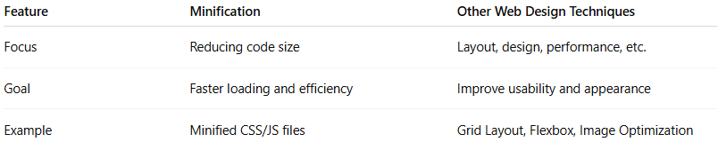
Feature | Minification | Other Web Design Techniques
Focus | Reducing code size | Layout, design, performance, etc.
Goal | Faster loading and efficiency | Improve usability and appearance
Example | Minified CSS/JS files | Grid Layout, Flexbox, Image Optimization

